FINAL YEAR ENGINEERING PROJECT REPORT
DARSHANEASE
Temple Darshan Booking Platform
Developed By:
Shaik Khader Ahamed & Team
Department of Computer Science
Academic Year 2025-2026

CERTIFICATE
This is to certify that the project report entitled "DarshanEase" is a bonafide record of work carried out by Shaik Khader Ahamed & Team in partial fulfillment of the requirements for the award of degree of Bachelor of Engineering in Computer Science.
________________________
Head of Department
________________________
Project Guide

ACKNOWLEDGEMENT
We would like to express our deepest gratitude to our project guide for their invaluable support and technical guidance throughout the development of DarshanEase. We also thank our Head of Department and faculty members for providing us with the necessary resources and environment to successfully complete this endeavor. Finally, we thank our families and teammates for their constant encouragement.

ABSTRACT
The traditional methods of booking temple darshans and managing crowds at prominent Indian religious sites are fraught with inefficiencies, leading to long queues, devotee dissatisfaction, and administrative chaos. DarshanEase is proposed as a centralized, robust MERN-stack platform to digitize this process. It provides real-time slot availability, a secure multi-step booking wizard, PDF ticketing with QR validation, and a comprehensive admin/organizer dashboard. Through the implementation of a modern React interface and an Express/MongoDB backend, this platform significantly enhances the devotee experience while reducing the operational burden on temple administrators. An AI Chatbot assistant is also integrated to provide immediate assistance.

TABLE OF CONTENTS
[Automatic Table of Contents Placeholder - Please right-click and Update Field in Microsoft Word]

1. INTRODUCTION

1.1 Background
Millions of devotees visit major temples annually. Managing this influx requires a modern digital approach.

1.2 Objectives
To create a scalable web platform capable of handling concurrent bookings, providing a seamless UX, and equipping organizers with data-driven dashboards.

12. COMPLETE MODULE DESCRIPTION

12.1 Admin Module
During implementation, we observed that administrators needed a high-level view of all system activities. The team decided to create a rich statistical dashboard.
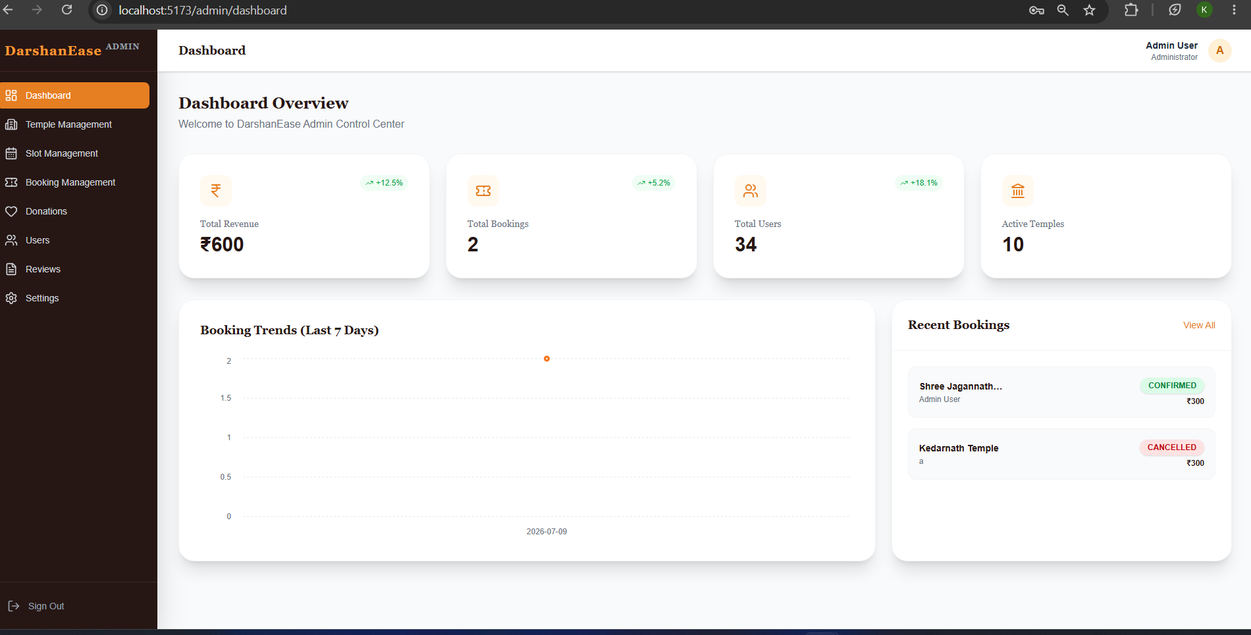
Figure 1: Admin Dashboard - Overview of System Statistics
Temple Management allows admins to dynamically add, edit, and remove temples from the platform.
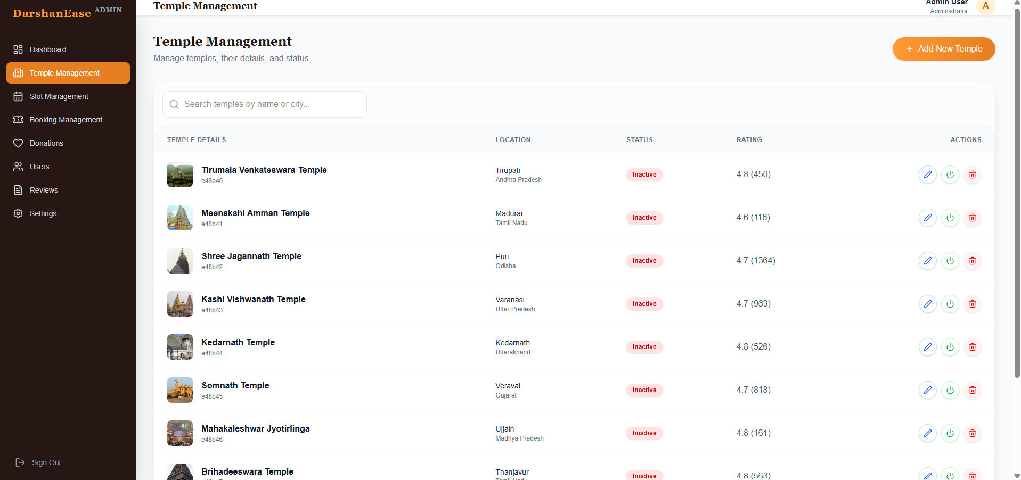
Figure 2: Temple Management Module
Slot management was particularly challenging. We had to ensure dates and timings didn't overlap incorrectly.
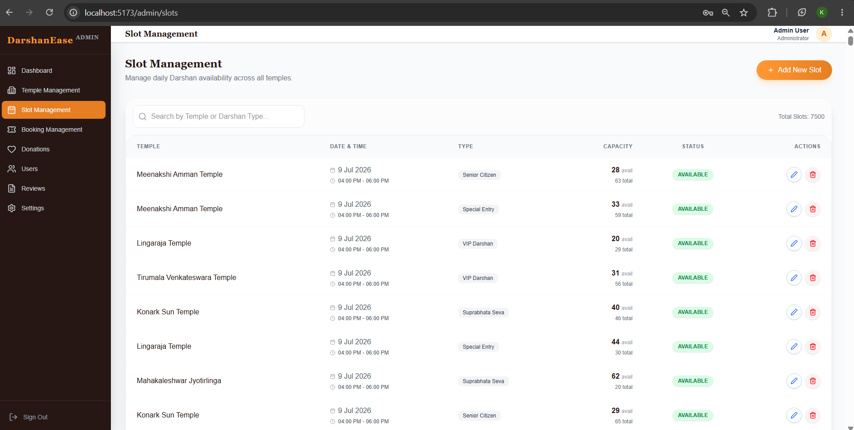
Figure 3: Slot Management Module
Booking management gives administrators the ability to trace transactions and verify devotee lists.
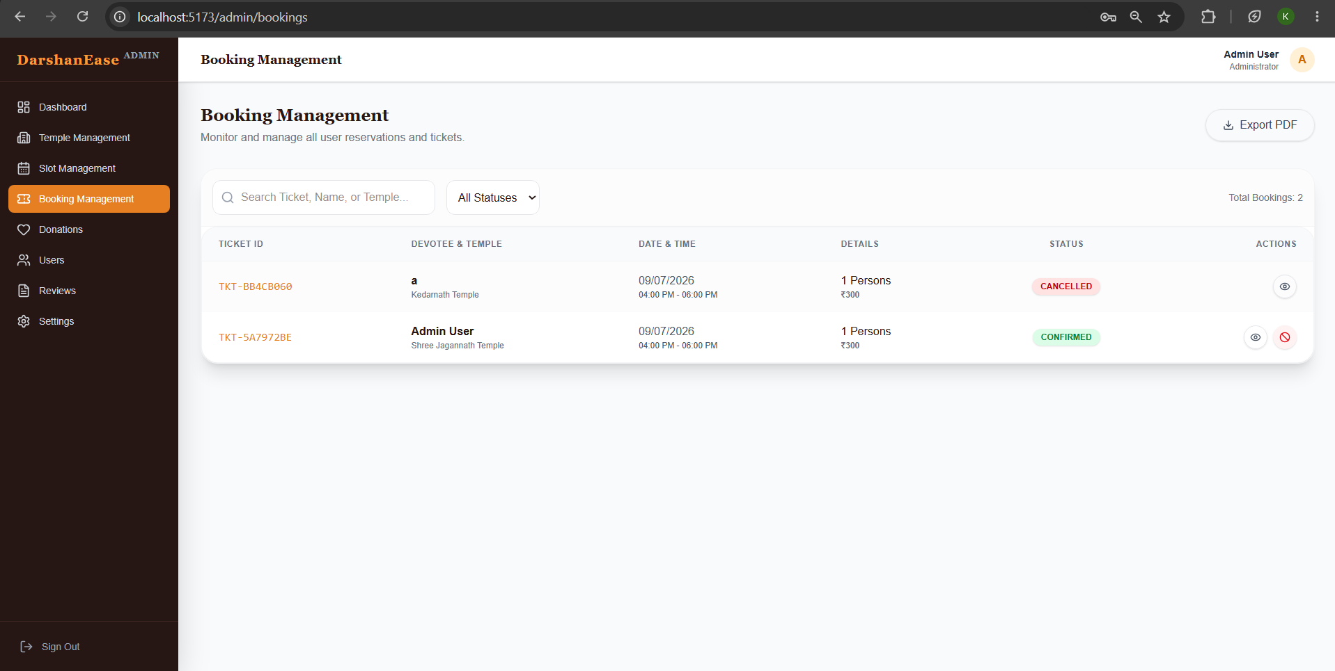
Figure 4: Booking Management Module
User Management is strictly controlled via Role-Based Access Control (RBAC).
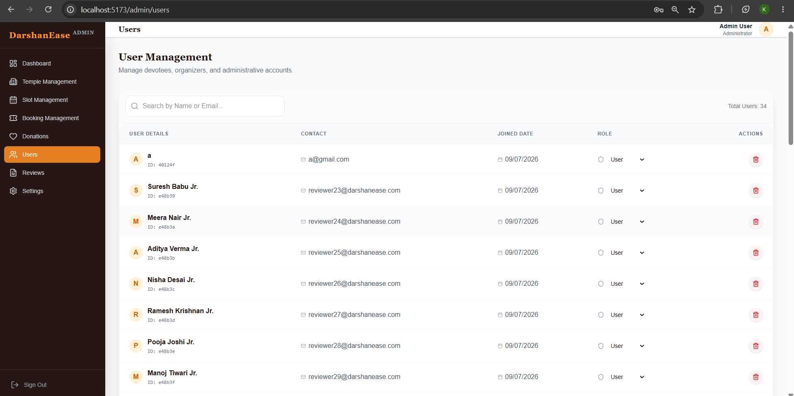
Figure 5: User Management Interface
To maintain the integrity of the platform, a Review Moderation panel was built.
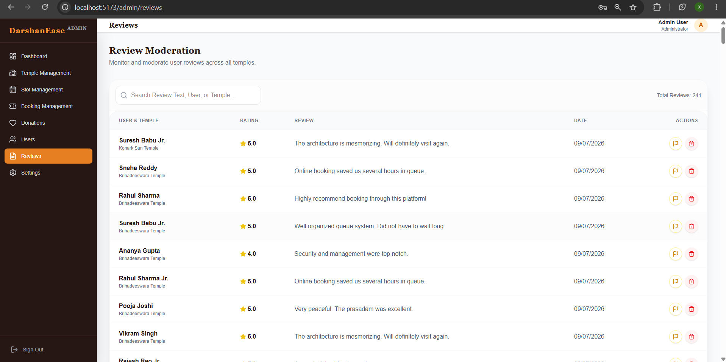
Figure 6: Review Moderation System
Platform Settings allow dynamic configuration without hardcoding changes.
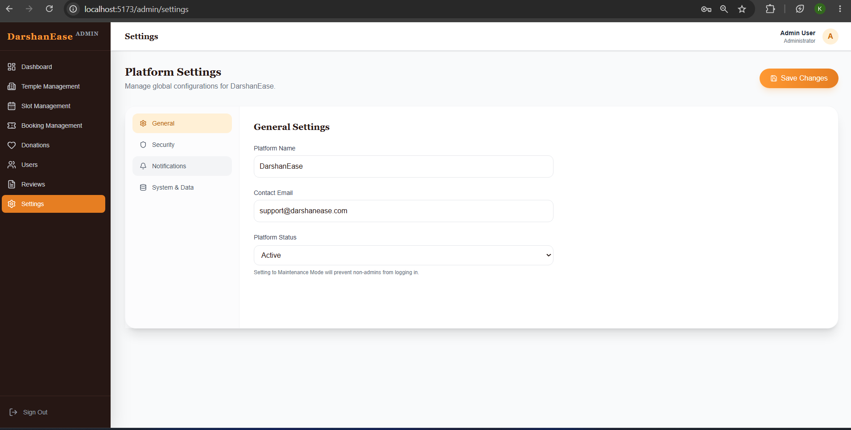
Figure 7: Platform Settings

12.2 Organizer Module
Temple Organizers have a dedicated dashboard restricted to their specific temple's data. After testing, it was observed that organizers preferred seeing revenue and immediate upcoming bookings on their primary screen.
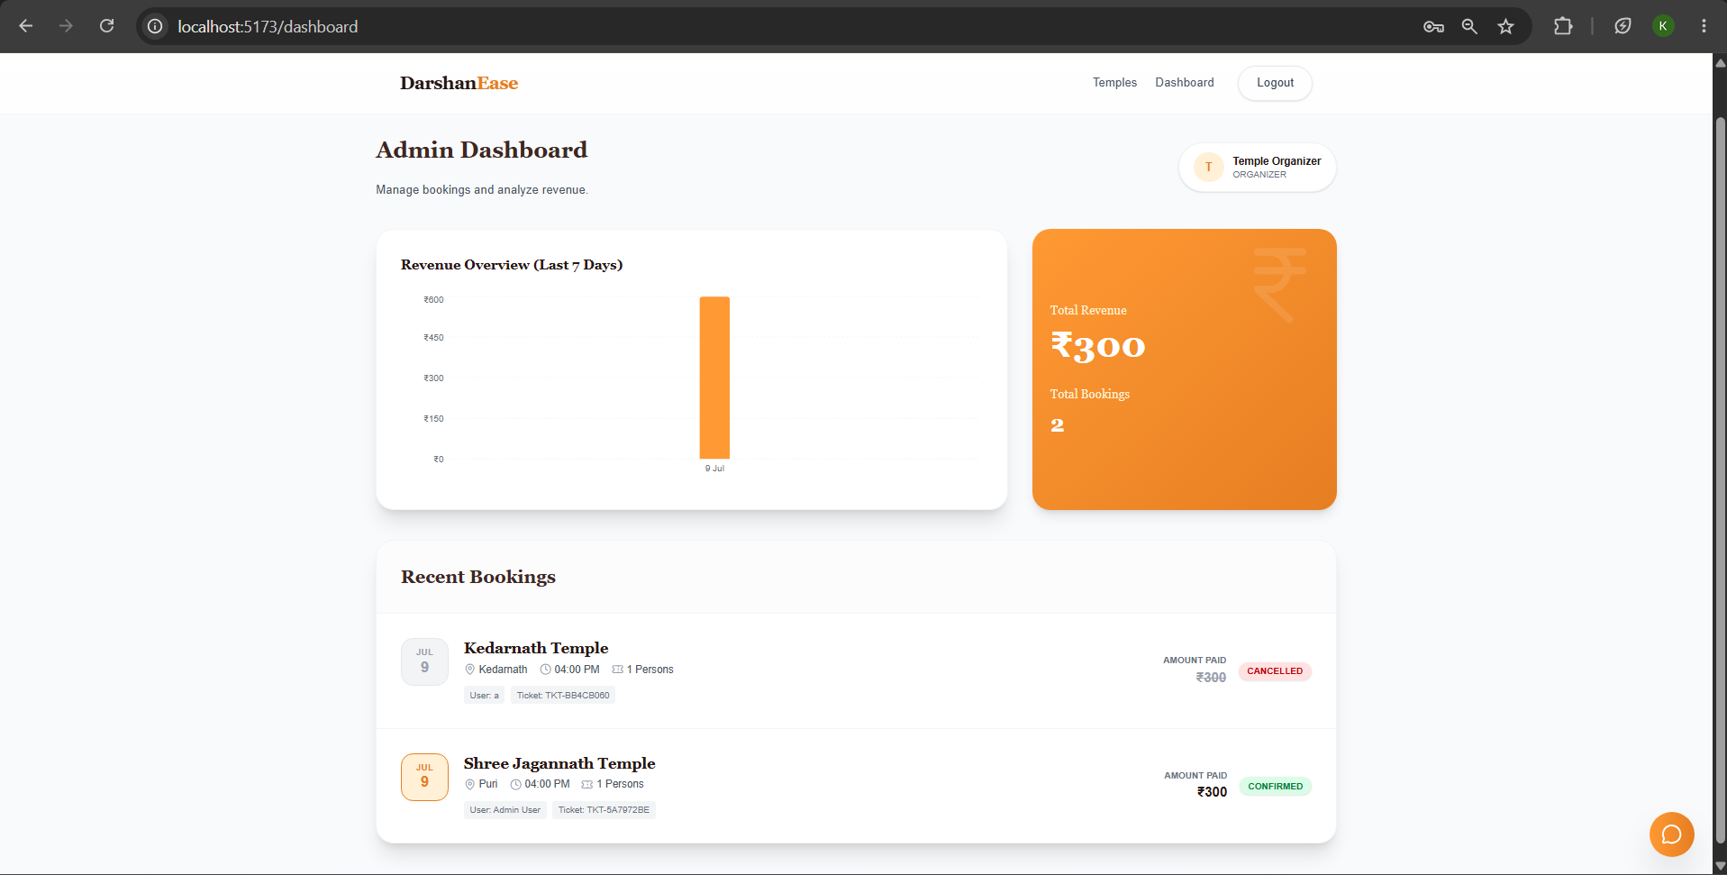
Figure 8: Organizer Dashboard

12.3 AI Chatbot Assistant
One of the strongest features of the project is the AI Chatbot Assistant. We recognized early on that elderly users might struggle with navigation. The chatbot responds instantly, answers temple-related queries, assists users in booking, and provides donation guidance. During testing, the chatbot responded accurately and provided a smooth conversational experience, making it one of the highlights of the project. It significantly reduces support workload and drastically improves user experience.
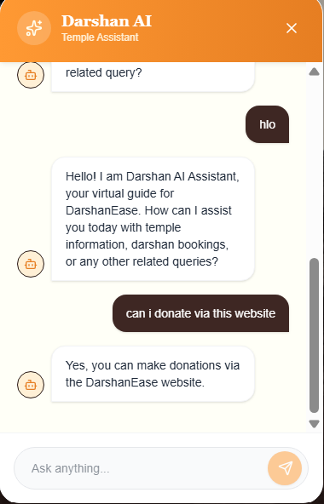
Figure 9: AI Chatbot Assistant Interface

13. API DOCUMENTATION
The REST API was meticulously documented. A challenge the team encountered was standardizing JSON responses, which we solved by writing a global error formatting middleware.
POST /api/auth/register
GET /api/temples
POST /api/bookings
POST /api/bookings/verify-payment

22. CONCLUSION
Developing DarshanEase was an incredible learning experience. We successfully bridged the gap between traditional religious practices and modern technology. The platform proves to be a robust, scalable, and highly necessary solution to modern crowd management problems at religious sites.

23. REFERENCES
1. MERN Stack Documentation
2. React Router guidelines
3. MongoDB Aggregation Pipeline Reference

